Robot V 1.24

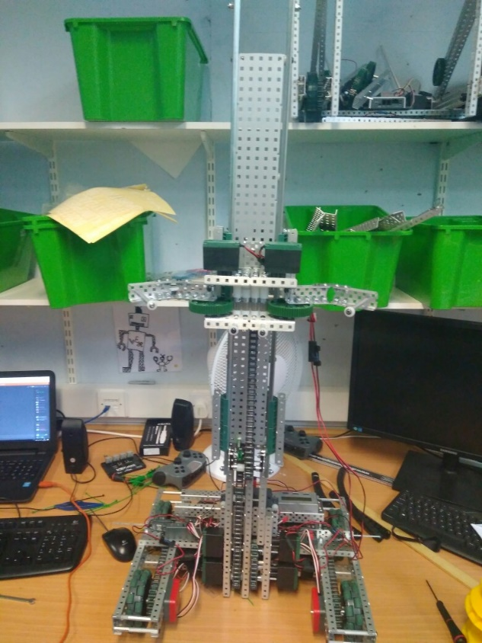

SPECIFICATIONS:

* 6 Motor HS drive
* Two drive chains
* 4 wheels
* Aluminium structure
* 4 motor lift
* Three stage lift
* 2 motor claw

DIMENTIONS:

17.5” * 15” * 17.5 when not extended

**What needs to be changed:**

* Plug in shaft encoders
* Fix chain skipping problem
* Cable manages

By Robbie Buxton

18/7/2017 – 16:12

**Overview:**

For this version of the robot we have remounted the claw. We also managed to fix the problem with the robot being slanted by losing then tightening all the screws holding the lift in place. We have found that when the robot starts to lift heavier weights the main chain in the lift begins to skip gears. This is a huge problem if we cannot fix it as it basically invalidates the purpose of this robot as being a multi-role robot able to lift Mobile goals as well and cones on the same lift. As well as fixing that problem we also need do some cable management and plug the shaft encoders in.

**WHAT HAS BEEN CHANGED:**

* Mounted claws
* Made it straight